Hobbies of your Nokia colleagues: ultrarunning TAI

Hobby of your Nokia colleague: ultrarunning TAI

My Hobby: ultrarunning  
  
My name is Mikael and I’m an addict….ultrarunner. Running has always been part of my life. It is sort of a lifestyle although that might sound like a cliché.

Already as a child running was part of my life in the form of orienteering. We used to attend orienteering competitions almost every weekend with my parents and sister during the summer. At the age of 18 I wanted to try my first marathon which was not a big success. I had started way too fast to be able to complete the race gracefully. Even with the less expected result I didn’t give up but continued to run marathons. However, I never quite achieved the results I strived for.

It was in early 2000 when I heard about ultrarunning for the first time. I came across a couple of articles about runners who ran across Australia and another runner who had run between the Paavo Nurmi statues in Helsinki and Turku. Those inspired me and in 2004 I ran my first ultra. It was a 6-hour race on a 400-meter track. After the race I had a feeling that I have found something profoundly new for myself. Something I had never experienced before.

Running ultra distances is quite different compared for example to marathons. The pace is always much slower and you have time to discuss with people even during the race. It’s a very social event where you can meet with extraordinary people and hear great stories from all around the world. The running community is also much smaller which means you know many if not all of the runners.

Since the first ultra race the sport has taken me all over the world. I have been running in the beautiful Japan during the cherry tree blossom in April, around the gigantic Mont Blanc in August and under the scorching sun in Rocky Mountains Canada in July. One of the most memorable races has also been running under the midnight sun in arctic nature in Lapland. Since the beginning I have done more than 50 ultra races.

I would advise everyone to try running. Running is a nice way to familiarise yourself while travelling to a new environment. You may often find new and exciting places that you would not otherwise find. There are nice applications available which you can use in advance to plan your runs in a new place. Or you may also contact the local running community to give you a tour to the nicest locations. Running is also a very time efficient sport since you do not need to separately go to a gym or sports arena. You just open your front door at home and take the first step. Now when working from home office during the covid-19 it is quite nice to have a short break during the day and go for a run. This helps also your cognitive capabilities during the rest of the day.

For the last two years I have together with my wife also produced a podcast series called Polkuporinat. The idea has been to discover and document different stories around endurance sports. Some of the people we have invited to the series might be familiar also to you as they have been invited also to different Nokia events. You can listen to the series with any podcast application or behind this link: <https://radioplay.fi/podcast/polkuporinat/> The podcast series is in Finnish.

Happy running,

Mikael

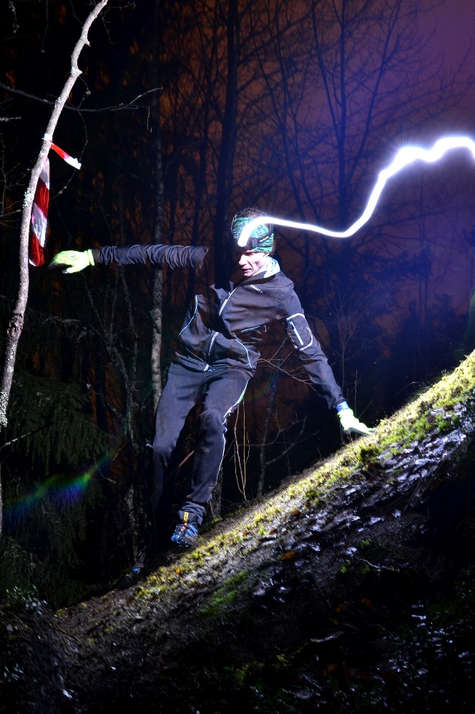 Sysikallio 2011

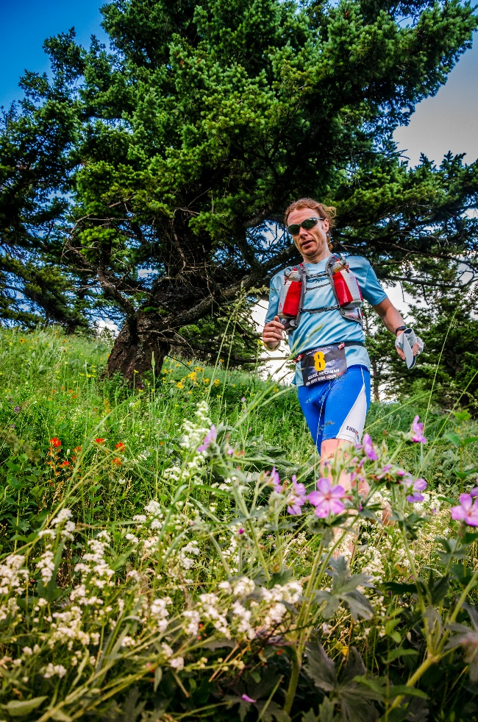 Sinister 7 2014 (Canada Rocky Mountains)

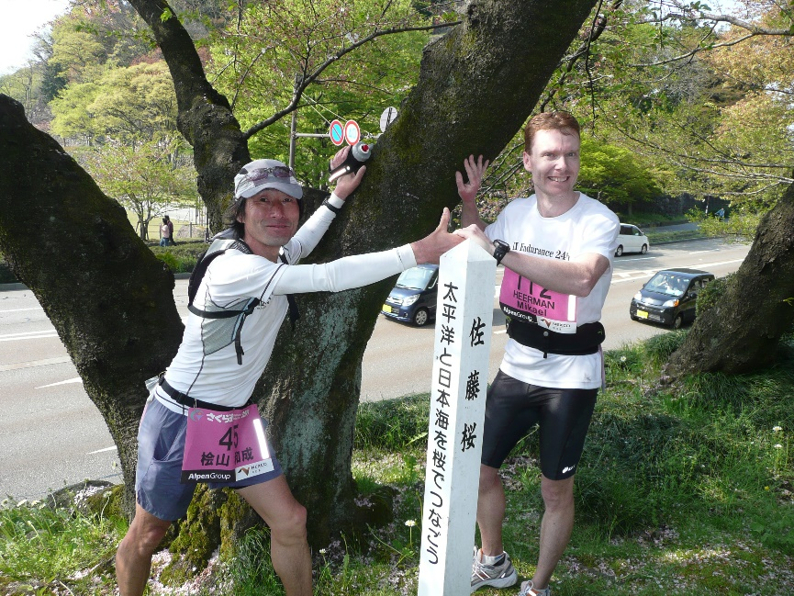 Sakura-michi 2009

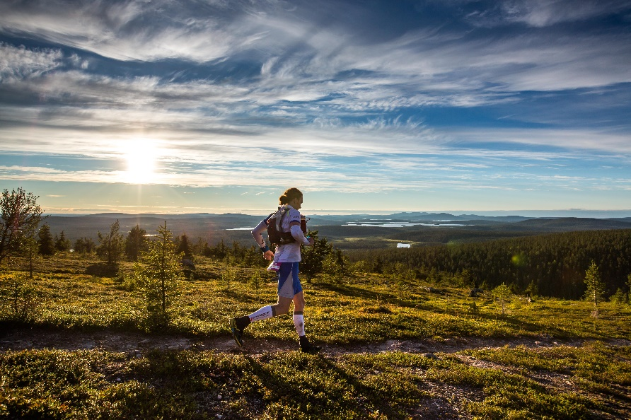 Pallas 2016

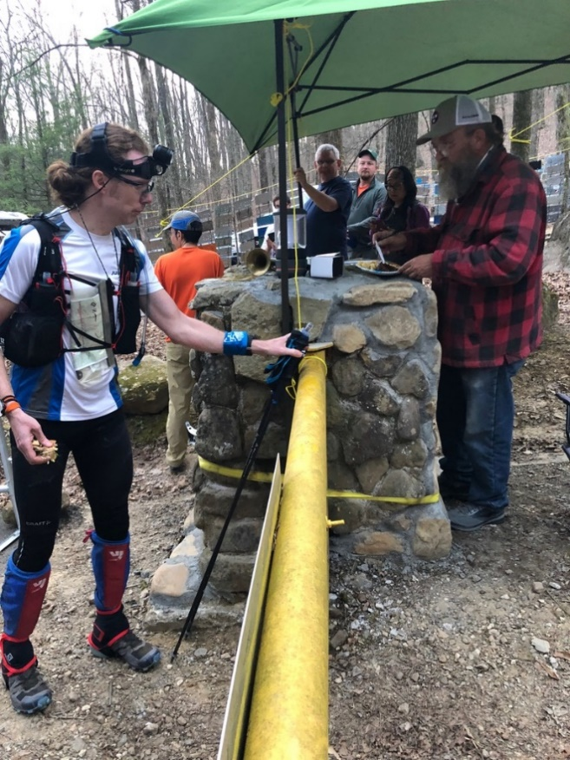 Barkley Marathons 2019 start of loop 2

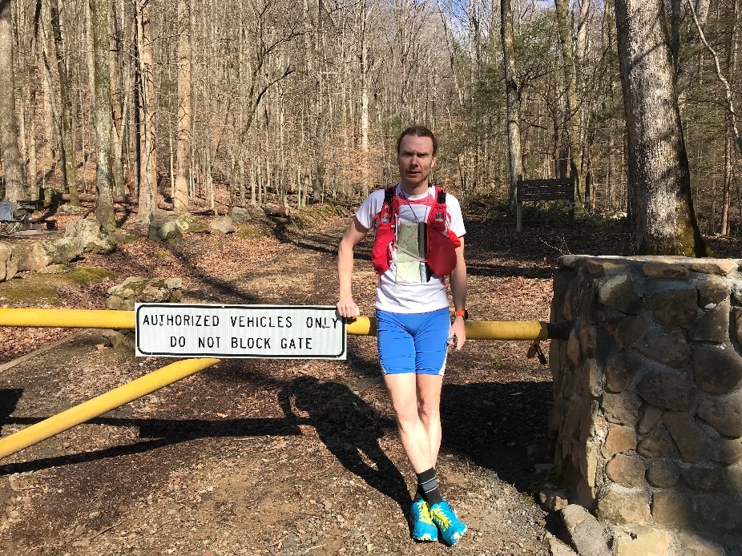 Barkley yellow gate 2019